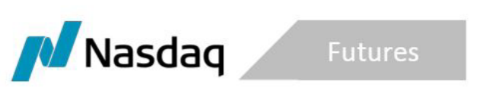
SR-NFX-2020-01 Exhibit A

January 16, 2020

NFX Rebate Program for Closing Open Interest in Tanker Freight Futures Contracts

Introduction
Nasdaq Futures, Inc. (NFX or the Exchange), the designated contract market owned and operated by Nasdaq, is offering a Rebate Program to encourage market participants to close their existing open interest (“OI”) in Tanker Freight Futures Contracts (“Tanker Freight”). The Program will continue until January 31, 2020.
On November 12, 2019, NFX announced that it had sold the core assets of the Exchange to EEX Group. The Exchange is now encouraging market participants to close existing OI in Dry Freight, U.S. Power, U.S. Natural Gas and Crude Oil on the Exchange and establish substantially identical positions on the EEX platform, or its subsidiary, Nodal Exchange (“Nodal”). The Exchange is working closely with EEX and Nodal to facilitate this process of migrating OI. The migration process involves identifying OI on NFX, matching those positions with equal and opposite positions on the Exchange and then entering closing transactions to reduce the OI to zero. Market participants seeking to move their OI to EEX or Nodal may then establish substantially similar positions on one of those two platforms.

The migration structure that is currently being utilized for the transfer of the Dry Freight Futures and Options is not available since EEX does NOT list Tanker Freight products. As a result, customers with existing Tanker Freight positions on NFX will need to close them and re-establish those same positions on an exchange that supports Tanker Freight (currently CME and ICE). There will likely be additional costs that the migrating customers incur when moving to CME and/or ICE, as NFX does not have a migration arrangement for Tanker Freight with either exchange. Those additional costs could include exchange fees, voice broker fees, OCC fees, etc.
NFX will now offer a rebate to customers who incur expenses in transferring Tanker Freight positions. In order to qualify for the rebate, customers must satisfy the following three criteria:
- The customer must have held OI in Tanker Freight as of January 1, 2020,
- The Customer must have closed their entire Tanker Freight OI position by January 31, 2020, and
- The customer’s closing transaction must simultaneously reduce all NFX Tanker Freight OI to zero.

Customers will need to provide NFX with documentation of the cost of transferring their Tanker Freight position to another DCM in order to be eligible for the rebate. The maximum rebate allowed under the program will be $5,000 per customer.

