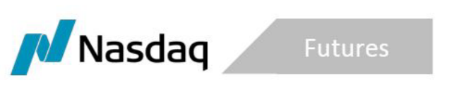
SR-NFX-2020-02 Exhibit A

January 17, 2020

NFX Energy Futures Clearing Fee Rebate Program
Introduction
NFX is offering a Rebate Program to encourage market participants to close their existing open interest (“OI”) in U.S. Power, U.S. Natural Gas and Crude Oil Futures Contracts (“Energy Futures”). The Program will continue until April 1, 2020.
The terms of the Rebate Program are as follows:
- NFX will rebate all OCC clearing fees incurred by market participants when closing Energy Futures OI on NFX between February 1, 2020 and April 1, 2020
- By April 1, 2020, the market participant must have closed all existing Energy Futures OI on NFX
Customers will need to provide NFX with documentation of the clearing fees assessed by OCC for closing all Energy Futures positions in order to be eligible for the rebate.

