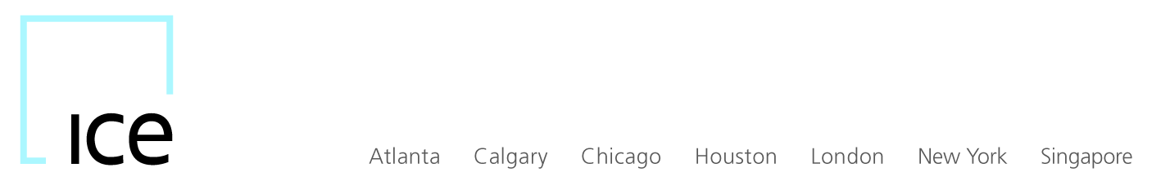

BY ELECTRONIC TRANSMISSION

Submission No. 19-8 January 30, 2019

Mr. Christopher J. Kirkpatrick
Secretary of the Commission
Office of the Secretariat
Commodity Futures Trading Commission
Three Lafayette Centre
1155 21st Street, NW
Washington, DC 20581

Re: New SREC Free to Post Incentive Program
Submission Pursuant to Section 5c(c)(1) of the Act and Regulation 40.6

Dear Mr. Kirkpatrick:

Pursuant to Commodity Futures Trading Commission (“CFTC”) Regulation 40.6(a), ICE Futures U.S., Inc. (“IFUS” or “Exchange”) hereby submits by written certification, the terms and conditions of the new SREC Free to Post Incentive Program (“Program”), which will become effective on February 14, 2019. The terms and conditions of the Program are set forth in Exhibit A.

The Exchange certifies that the Program complies with the requirements of the Commodity Exchange Act and the rules and regulations promulgated thereunder. In particular, the Program complies with Core Principle 4 (Monitoring of Trading), Core Principle 9 (Execution of Transactions) and Core Principle 12 (Protection of Market Participants). The Program does not impact order execution priority or otherwise give participants any execution preference or advantage. In addition, the Exchange’s Market Regulation Department actively monitors for trading abuses using electronic exception reports and will take appropriate action against any participants engaging in market abuses.

The Exchange is not aware of any opposing views with regard to the Program and further certifies that, concurrent with this filing, a copy of this submission was posted on the Exchange’s website at (https://www.theice.com/futures-us/regulation#rule-filings).

If you have any questions or need further information, please contact me at 212-748-4021 or at jason.fusco@theice.com.

Sincerely,
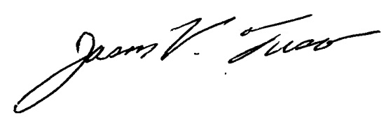

Jason V. Fusco
Assistant General Counsel
Market Regulation

Enc.
cc: Division of Market Oversight
New York Regional Office

EXHIBIT A
ICE Futures SREC Futures Contract Free to Post Incentive Program

Program Purpose

The purpose of the Program is to incentivize participants to increase liquidity in the products listed below; this enhanced liquidity will benefit all participants in the marketplace.

Product Scope

New Jersey Solar Renewable Energy Certificate (“NJSREC”) and Massachusetts Solar Renewable Energy Certificate (“MASREC”) futures contracts, all vintages.

Eligible Participants

IFUS may designate three (3) participants in the Program, who may be Exchange members or non-members. In order to be considered for selection into the Program, potential participants must have maintained a sufficient volume in program or other Exchange Environmental contracts over the past three months at the time of application. Notwithstanding the foregoing the Exchange may add or subtract from the aforementioned criteria as it deems necessary.

Program Term

The initial term of the program will end on December 31, 2019.

Obligations

Participants are required to provide the Exchange with information acceptable to the Exchange detailing Participants’ trading activity under the program, and the Exchange may require an additional third party verification report.

Program Incentives

[PARAGRAPH REDACTED]

Monitoring and Termination of Status

The Exchange shall monitor trading activity and Participants’ performance and shall retain the right to revoke Participants’ status if it concludes from review that a Program Participant has failed to meet its obligations or no longer meets the eligibility requirements of this Program.

