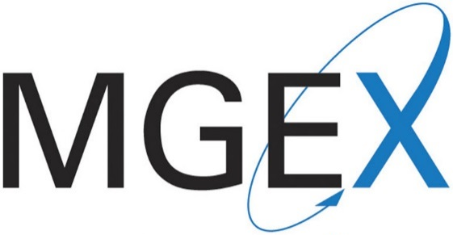

Via Portal Submission February 19, 2016
MGEX Submission No. 16-4
Mr. Christopher J. Kirkpatrick
Secretary of the Commission
Commodity Futures Trading Commission
Three Lafayette Centre
1155 21st Street NW
Washington, DC 20581

RE: Weekly Notification of Rule Amendments Pursuant to Regulation 40.6(d)

Dear Secretary Kirkpatrick:

Pursuant to Commodity Exchange Act Section 5c and Commodity Futures Trading Commission Regulation 40.6(d), the Minneapolis Grain Exchange, Inc. (“MGEX”) submits this Weekly Notification of the following rule amendments made effective during the week of February 10, 2016:

- February 10, 2016 Memo to MGEX Members and Market Participants advising of the schedule and hours for the upcoming Presidents’ Day holiday and surrounding trading days.

A copy of the above-referenced memo is available at http://www.mgex.com under the “Announcements” tab. If there are any questions regarding this submission, please contact me at (612) 321-7141 or awysopal@mgex.com.

Sincerely,
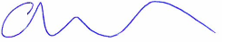
Adam Wysopal
Assistant Corporate Counsel

