March 10, 2020

Christopher J. Kirkpatrick

Office of the Secretariat

Commodity Futures Trading Commission

Three Lafayette Center

1155 21st Street, NW

Washington, DC 20581

**Re: SR-NFX-2020-08**

**De-Listing of Certain NFX Contracts**

Dear Mr. Kirkpatrick:

On November 12, 2019, Nasdaq Futures, Inc. (“NFX” or the “Exchange”) announced it had agreed to sell the majority of its exchange assets to EEX Group. Under the terms of this agreement, NFX will facilitate the transfer of all existing open interest in futures and futures options in Crude Oil, Ferrous Metals, Dry Bulk Freight, U.S. Natural Gas and U.S. Power to Nodal Clear and European Commodity Clearing (“ECC”).

As part of this transaction, NFX will commence the process of de-listing the futures and futures options contracts listed in the attached Exhibit A. NFX certifies that all contracts being de-listed have no open interest at the present time. The Exchange will de-list additional futures and futures options contracts in the coming months as Open Interest continues to move to Nodal Clear and ECC.

If you require any additional information regarding this submission, please contact Aravind (Andy) Menon at (301) 978-8416 or [aravind.menon@nasdaq.com](mailto:aravind.menon@nasdaq.com) at your earliest convenience. Thank you for your attention to this matter.

Regards,

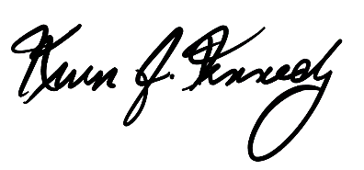

Kevin Kennedy

Chief Executive Officer

cc: Gregory Kuserk, Deputy Director, Product Review Branch, CFTC

Nancy Markowitz, Deputy Director, Market Review Branch, CFTC

Exhibit A: List of Futures and Futures Options Contracts Being De-Listed from NFX