February 24, 2020

Christopher J. Kirkpatrick

Office of the Secretariat

Commodity Futures Trading Commission

Three Lafayette Center

1155 21st Street, NW

Washington, DC 20581

**Re: SR-NFX-2020-11**

**De-Listing of the NFX WTI Crude Oil Last Day Financial Futures (CLQ)**

Dear Mr. Kirkpatrick:

On November 12, 2019, Nasdaq Futures, Inc. (“NFX” or the “Exchange”) announced it had agreed to sell the majority of its exchange assets to EEX Group. Under the terms of this agreement, NFX is completing the transfer of all existing open interest (“OI”) in futures and futures options in Dry Bulk Freight, U.S. Natural Gas and U.S. Power to Nodal Clear and European Commodity Clearing (“ECC”). NFX’s Crude Oil OI will not however be migrated to EEC or Nodal. Instead, as OI in these contracts close out, NFX will delist the contracts from its platform. Accordingly, NFX is now delisting the NFX WTI Crude Oil Last Day Financial Futures (CLQ). NFX certifies that the contract has no open interest at the present time. The Exchange will de-list additional futures and futures options contracts as OI continues to close on the NFX platform.

If you require any additional information regarding this submission, please contact Aravind (Andy) Menon at (301) 978-8416 or [aravind.menon@nasdaq.com](mailto:aravind.menon@nasdaq.com) at your earliest convenience. Thank you for your attention to this matter.

Regards,

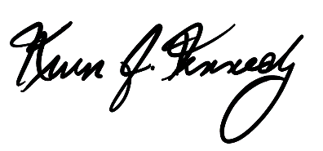

Kevin Kennedy

Chief Executive Officer

cc: Gregory Kuserk, Deputy Director, Product Review Branch, CFTC

Nancy Markowitz, Deputy Director, Market Review Branch, CFTC