Via Portal Submission August 18, 2022
MGEX Submission No. 22-35

Mr. Christopher J. Kirkpatrick
Secretary of the Commission
Commodity Futures Trading Commission
Three Lafayette Centre
1155 21st Street NW
Washington, DC 20581

RE: Weekly Notification of Rule Amendments Pursuant to Regulation 40.6(d)

Dear Secretary Kirkpatrick:

Pursuant to Commodity Exchange Act Section 5c and Commodity Futures Trading Commission Regulation 40.6(d), the Minneapolis Grain Exchange, LLC (“MGEX”) submits this Weekly Notification of the following rule amendments made effective the preceding week:

- August 5, 2022 Memo to MGEX Clearing Members advising of approved changes to clearing and exchange margin requirements for the Hard Red Spring Wheat spread margin rates. These changes were effective for positions held at the close of business on Monday, August 8, 2022.

A copy of the above-referenced memo is available at http://www.mgex.com under the “Announcements” tab. If there are any questions regarding this submission, please contact me at (612) 321-7143 or lhopkins@mgex.com.

Sincerely,
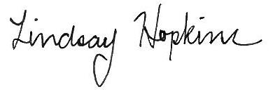
Lindsay Hopkins
Chief Corporate Counsel, Clearing

