August 28, 2019 Nasdaq Futures, Inc.

FMC Tower, Level 8,

Christopher J. Kirkpatrick 2929 Walnut Street

Office of the Secretariat Philadelphia, PA 19104 / USA

Commodity Futures Trading Commission

Three Lafayette Center business.nasdaq.com/futures

1155 21st Street, NW

Washington, DC 20581

**Rule Self-Certification: Rule Certification for Amendment to NFX Certificate of Incorporation**

**Reference File: SR-NFX-2019-28**

Dear Mr. Kirkpatrick:

Pursuant to Section 5c(c)(1) of the Commodity Exchange Act, as amended (“Act”), and Section 40.6 of the Commission’s regulations thereunder, NASDAQ Futures, Inc. (“NFX” or “Exchange”) hereby submits a rule amendment removing the Permit Fee. The Exchange anticipates the amendment going into effect on September 12, 2019 for trade date September 13, 2019.

**Fee Schedule – Permit Fee**

The Exchange is amending the rulebook to remove the Permit Fee. The Permit Fee is a $100 per annum fee assessed to each Futures Participant on the first of July each year. NFX initially waived this fee for calendar year 2015.[1] Since that time, NFX has not assess the Permit Fee to Futures Participants. The Exchange is now removing the fee completely.

**DCM Core Principles**

The Exchange has reviewed the designated contract market core principles (“Core Principles”) as set forth in the Act in connection with the amendment presented herein. Consistent with Core Principle 7 - Availability of General Information, the Exchange will post general information, including the NFX Rulebook as amended herein, on its website: [business.nasdaq.com/futures](http://business.nasdaq.com/nasdaq-futures/nfx-market).

**Certifications**

There were no opposing views among NFX’s Board of Directors, members or market participants. The Exchange hereby certifies that the rule amendment set forth herein complies with the Act and the Commission’s regulations thereunder. The Exchange also certifies that notice of pending certification and a copy of this submission have been concurrently posted on the Exchange’s website at [business.nasdaq.com/futures](http://business.nasdaq.com/nasdaq-futures).

If you require any additional information regarding the submission, please contact Aravind Menon at (301) 978-8416 or aravind.menon@nasdaq.com. Please refer to SR-NFX-2019-28 in any related correspondence.

Regards,

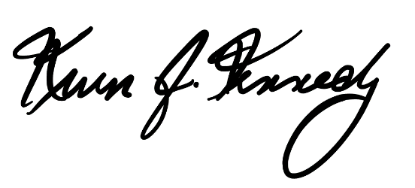

Kevin Kennedy

Chief Executive Officer

Attachments:

Exhibit A: Amendments to Rulebook Fee Schedule

1. See SR-NFX-2015-65, rule certification waiving Permit Fee and delaying implementation of the Regulatory Fee until May 1, 2016.