SR-NFX-2018-41 Exhibit C

Genium INETTM

TradeGuard User's Guide
NASDAQ Futures, Inc. (NFX)

Version: 4.1.122930

Document Version: 9

Publication Date: Wednesday, October 3, 2018 Wednesday October 3, 2018Confidentiality: Non-confidential

Genium, INET, ITCH, CONDICO, EXIGO, and TradeGuard are registered trademarks of Nasdaq, Inc. X-stream Trading, OUCH, ICS-II, SWIFT Gateway, Genium Market Info (GMI), Appmind, PRM, PTRM, MiQ, SMARTS, X-stream CSD, Genium Risk Manager (GRM), TIP, CLICK, CLICK XT, and SECUR are trademarks of Nasdaq, Inc.

Whilst all reasonable care has been taken to ensure that the details are true and not misleading at the time of publication, no liability whatsoever is assumed by Nasdaq, Inc., or any subsidiary of Nasdaq, Inc., with respect to the accuracy or any use of the information provided herein. Any license, delivery and support of software systems etc. require entering into separate agreements with Nasdaq, Inc. This document contains confidential information and may not be modified or reproduced, in whole or in part, or transmitted in any form to any third party, without the written approval from Nasdaq, Inc.

Copyright © 2018 Nasdaq, Inc. All rights reserved.

All rights reserved.

Table of Contents

Introduction 5
Purpose 5
Audience 5
References 5
Overview 6
Getting Started 7
System Requirements 7
Launching the Application the First Time 7
Window Layout 8
Expanding and Collapsing Panels 10
Understanding Intraday vs Next Day Changes 11
Intraday Changes 11
Next Day Changes 11
Understanding Breaches versus Blocks 13
Breaches 13
Manual Blocks and Monitored User Disconnect 13
Understanding Account Groups and User Groups 14
User-Based Groups 14
Account-Based Groups 14
Trader Panel 15
Notice, Warn, and Breach Notices in the Trader Panel 15
Restricted Instruments 16
Setting the Order Rate Limit 16
Setting Warn and Notice Percentages 19
Starting and Stopping Updates 19
Searching for Groups and Accounts 20
Pre-Trade Limit Groups Overview 21
Adding a Pre-Trade Limit Group 21
Deleting a Pre-Trade Limit Group 23
Mass Canceling Orders on a Group 24
Blocking a Pre-Trade Limit Group 24
Unblocking a Group 25
Unblocking an Order Rate Breach 26
Unbreaching a Tradeable Limit 26
Current Consumption Tab 27
Editing Limits Overview 28
Adding a Trade Limit 30
Editing Trade Limits 31
Deleting an Existing Trade Limit 33
Managing Email Alerts Overview 35
Setting Email Alerts 35
Adding New Email Alert Recipients 36
Editing Email Alert Recipients 37
Removing Email Alert Recipients 38
Managing Users Overview 41
Viewing Users 41
Adding a User to a Group 41
Removing a User From a Group 44
Changing or Removing a Monitored User 45
Default Group 48
Accounts Tab 49
Assigning Accounts 49
Removing Accounts 50
Appendix 52
Glossary 52
At-Trade 52
Monitored User 52
Pre-Trade 52
Pre-Trade Limits Group 52
Price Quotation Factor 52
Sponsored Client 52
Sponsoring Participant 52
Trade Report 52
Tradeable 52
Change Log 53

Introduction

Purpose
This user guide explains how to use the NFX Trading System to set limits on the risk exposure of order activity at an exchange.

Audience
This document is intended for NFX Trading System users that need to configure and monitor the real-time risk exposure by participants at NASDAQ Futures, Inc. (NFX).

References
None.

*****

Editing Limits Overview

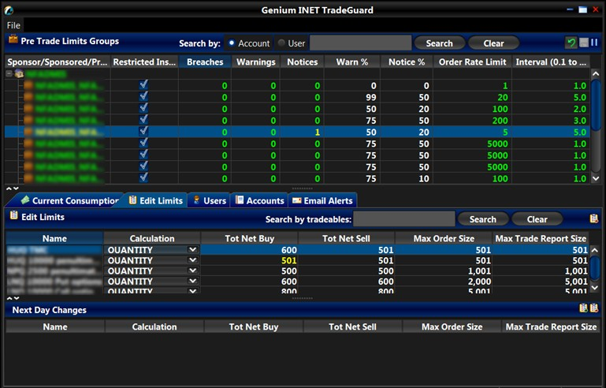

Edit Limits Tab

The risk exposure for a given tradeable limit will be all activity for that tradeable from all users or accounts in the Pre-Trade Limits Group. This combined exposure can be limited according to several calculations.
In the Genium INET TradeGuard application, a limit is set by defining the following parameters:
- An instrument class, instrument type (regular or combination), or an Instrument Class Limit Group (ICLG). All limits set will operate on the instruments belonging to an instrument class, type, or ICLG.
- A calculation type for the exposure value. This can be one of the following:
  - Quantity: The exposure is calculated by summing the share quantity for each order submitted by members of the group.
  - Volume: The exposure is calculated by summing the volume (shares * price quotation factor) of all orders submitted by members of the group.
- One or more limits to the following risk parameters:
  - Total Net Buy: Traded Bought – Traded Sold + Open Buy orders for the Tradeable.
  - Total Net Sell: Traded Sold – Traded Bought + Open Sell orders for the Tradeable.
  - Max Size: A pre-trade limit on the total computed exposure of a regular order. If an order exceeds the limit it is rejected before being accepted by the exchange.
  - Max Trade Report Size: A pre-trade limit on the total computed exposure of a trade report transaction. Any trade report that equals or exceeds the limit is rejected before being accepted by the exchange.

Pre-trade Risk Checks

The NFX version of TradeGuard enforces position limits in a pre-trade fashion. This means that the impact of an order on the defined limits is inspected before it goes to the exchange. If an order would cause a breach, then it will be rejected. Other versions of TradeGuard analyze trades in a at-trade fashion. After
a trade is executed, the effect of that execution is added into risk counters. When this causes a breach of limits, subsequent orders are rejected.

Breached Limits
If any of the risk limits are exceeded, the system rejects new orders submitted in any of the instruments connected to the affected Tradeable from any of the User IDs, or account IDs, that are part of the group. However, a user can still cancel open orders for the affected instrument when the limit is breached.
Note:
- Because the NFX engine enforces limits in a pre-trade fashion, breaching limits is somewhat rare. However, this can happen if a limit is reduced to less than a group's current exposure.
- TAS (Trade at Settlement) instruments count as derivative instruments to their reference series. This means that limits cannot be placed on individual TAS instruments. Instead their risk exposure is automatically contributed to limits on the reference series.
You can search to view or edit the limits for a specific tradeable using the search functionality. To search for specific tradeables, enter the tradeable in the Search by tradeables field and then click search. To clear results, click the Clear button.

Instrument Class Limit Groups
Instead of setting up a single limit, you can assign an Instrument Class Limit Group (ICLG) for the PTLG. Limits that are applied to the ICLG apply to all of the instrument classes that are associated with the ICLG. The consumption will be aggregated for all the classes associated with the ICLG. You can assign an
ICLG to a PTLG by adding the group as a tradeable in the Edit Limits tab, and set the calculation and risk parameters as you would with any tradeable.
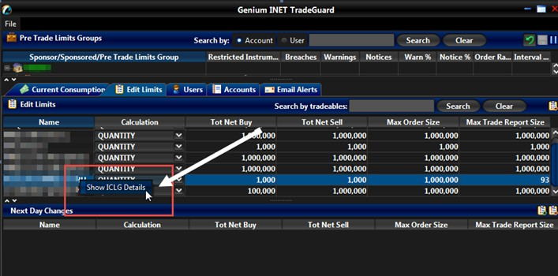
Once an ICLG is added to a PTLG, you can right-click the ICLG and click Show ICLG Details to view the instrument classes that are included in the ICLG. This menu is disabled for tradeables that are not an ICLG.

Adding a Trade Limit
To add a new trade limit to a Pre-Trade Limits Group, complete the following steps:
1) Click the group for which you want to edit limits, and then click the Edit Limits tab.

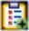
2)
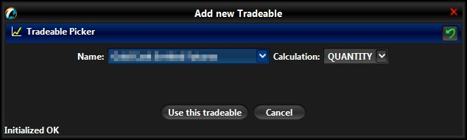
Click the Add new Tradeable button. The Add new Tradeable window displays.

Adding a Limit
- Select an instrument:
  - Name: The name of the tradeable to monitor.
Note: The instruments listed will only show regular and combination instrument classes and
types specified in the Legal Instrument Type for the user logged in.

- Select the calculation method for the limit:
  - Quantity: The exposure is calculated based on the share quantity of all orders.
  - Volume: The exposure is calculated based on the volume (shares * price quotation factor) of all orders.
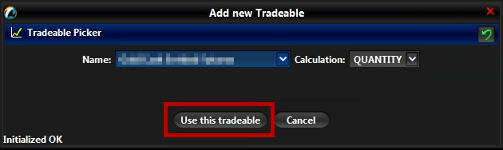
- Click the Use this tradeable button.

Use This Tradeable Button

A row with the new tradeable instrument will appear in the Edit Limits panel.
- Set any limits to be enforced on the selected securities.
When a new tradeable is added it will have the most restrictive limits set on it by default. This will be a limit of 1 for all rick checks. Raising limits to reasonable levels, or disabling certain limits with a 0 setting, must then be done manually for each risk check on the Tradeable.

Note:
A limit value of zero means no limit, and no breach is possible for that risk counter.
- Click the Save button.

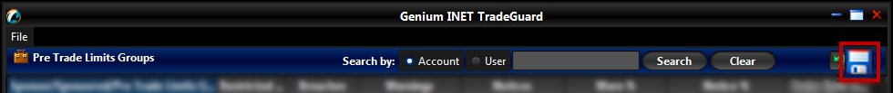

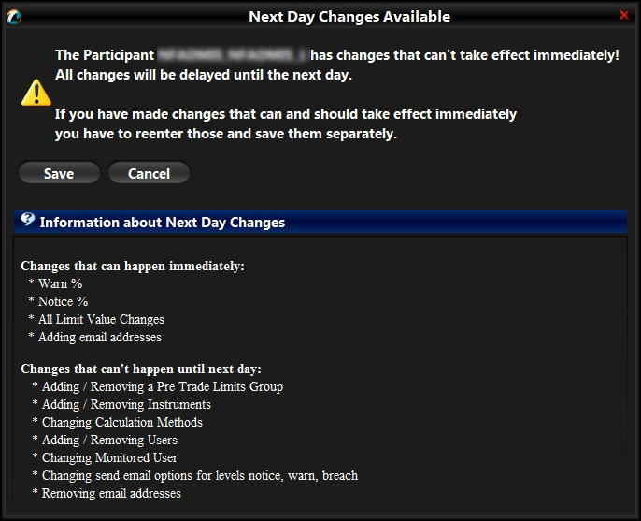
The Next Day Changes Available confirmation window appears.

Next Day Changes Save Button
- Click the Save button.
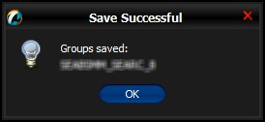
The Save Successful dialogue box appears confirming your changes for the group or groups you have changed.

Save Successful Dialogue Box
- Click the OK button to confirm your change.
Note:
This is a next day change. Saving the change sends it to the exchange database and becomes effective when the system is started the next day. See next day change for more information about next day changes.
Changing an Already Added Next Day Change
If you add a next day change, and you need to modify that next day change before the next day, you must delete that change and then add a new one.

Editing Trade Limits
To edit a limit on a Pre-Trade Limit Group, complete the following steps:

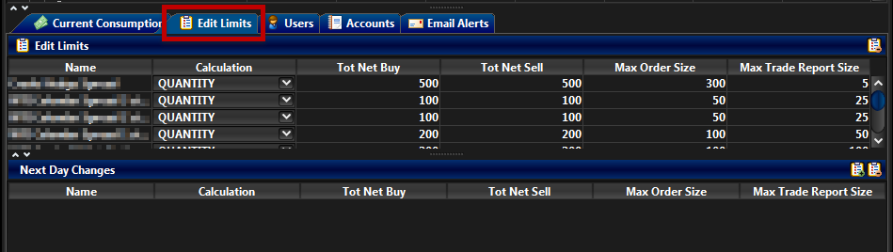
- From the Genium INET TradeGuard window, click the group for which you want to edit limits, and then click the Edit Limits tab.

Limits for a Group
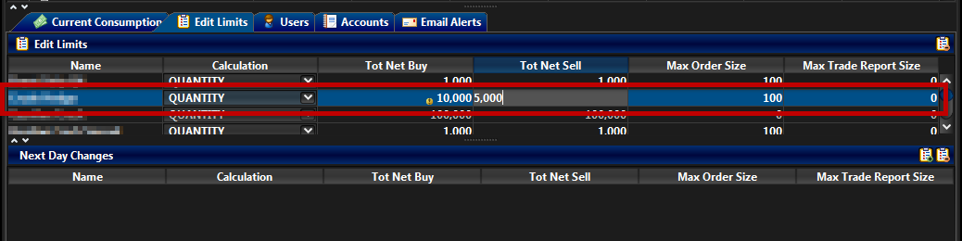
- In the Same Day Changes panel, review or change the fields as necessary. See the Editing Limits Overview for definitions of any of the fields.

Limits for a Pre-Trade Limit Group
- Click the Save button.
The Save Successful dialogue box appears confirming your changes for the group or groups you have changed.

Save Successful Dialogue Box
- Click the OK button to confirm your change.
Note:
Changing a trade limit can be either an intraday day or a next day change. If the change only affects risk counter limits, it will be an intraday change.
If the change affects the limit calculation, the limit will appear in the Next Day changes panel and be applied the next day.

Note:
- Setting a limit to zero disables the pre-trade limit check.
- Changing a limit from zero to a non-zero value intra-day may cause unpredictable results. RX does not accumulate intraday activity when the limit is set to zero.

Deleting an Existing Trade Limit
To delete an existing trade limit to on a group, complete the following steps:
- Click the Pre-Trade Limit Group for which you want to edit limits, and then click the Edit Limits tab.
- In either the Same Day Changes or the Next Day Changes panel, select the limit to delete.
- In the appropriate panel, click the Remove Tradeable button.
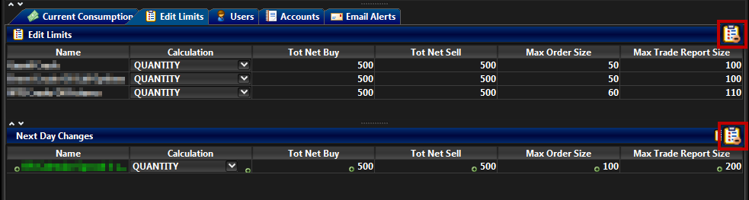

Deleting a Trade Limit
- Click the Save button.

Saving Changes to the Group

The Next Day Changes Available confirmation window appears.
- Click the Save button.

Next Day Changes Save Button

The Save Successful dialogue box appears confirming your changes for the group or groups you have changed.

Save Successful Dialogue Box
- Click the OK button to confirm your change.
After you delete the trade limit click the Save button, the limit will appear in the Next Day Changes panel and be removed the next trading. The limit will appear in the Next Day Changes panel and be removed the next trading.
Note:
This is a next day change. Saving the change sends it to the exchange database and becomes effective when the system is started the next day. See next day change for more information about next day changes.
Changing an Already Added Next Day Change
If you add a next day change, and you need to modify that next day change before the next day, you must delete that change and then add a new one.

*****

Change Log

Revision | Date | Description
1 | 25/Feb/2015 | First release for NFX. Update content for addition of Accounts tab.
2 | 09/Apr/2015 | Change application name from PRM to TradeGuard and update screen shots with new logos.  Add Max Trade Report risk check.
3 | 05/May/2015 | Corrections for some screenshots.
4 | 02/Jun/2015 | Restricting Instruments is no longer available from the TradeGuard application.  When a new tradeable is added to a group, the limits for all risk checks default to 1. Changed content in Adding a Trade Limit and Adding a Pre- Trade Limit Group.
5 | 21/Nov/2016 | Added the filters on the Current Consumption tab, and the search functionality to the Edit Limits and Current Consumption tabs. Added the Interval column in the PTLG display.
6 | 25/Apr/2017 | Added the information about canceled trades in the current consumption tab.
7 | 09/Jun/2017 | Updated the copyright information.
8 | 29/May/2018 | Updated with the new Instrument Class Limit Group functionality in the Edit Limits section of the user guide.
9 | 30/May/2018 | Updated with changes from peer review.

