November 1, 2018 Nasdaq Futures, Inc.

FMC Tower, Level 8,

Christopher J. Kirkpatrick 2929 Walnut Street

Office of the Secretariat Philadelphia, PA 19104 / USA

Commodity Futures Trading Commission

Three Lafayette Center business.nasdaq.com/futures

1155 21st Street, NW

Washington, DC 20581

**Rule Self-Certification: Rule Certification for Amendments to the**

**Energy Broker Incentive Program**

**Reference File: SR-NFX-2018-55**

Dear Mr. Kirkpatrick:

Pursuant to Section 5c(c)(1) of the Commodity Exchange Act, as amended (“Act”), and Sections 40.2 and 40.6 of the Commission’s regulations thereunder, NASDAQ Futures, Inc. (“NFX” or “Exchange”) submits this self-certification to amend the Exchange’s broker incentive program (the “Energy Broker Incentive Program” or “Program”) for certain energy contracts (the “Energy Contracts”).1 This self-certification adds the newly listed Argus Crude Futures and simplifies the references to the OPIS Petrochemical Futures. Furthermore, the amendment extends the Program until May 31, 2019. The terms and conditions of the Energy Broker Incentive Program are attached hereto as Exhibit A. The amendments in Exhibit A will be implemented on November 15, 2018.

There were no opposing views among the NFX’s Board of Directors, members or market participants. The Exchange hereby certifies that the amendments to the Energy Broker Incentive Program comply with the Commodity Exchange Act and regulations thereunder. The Exchange also certifies that notice of pending certification and a copy of this submission have been concurrently posted on the Exchange’s website at business.nasdaq.com/futures.

If you require any additional information regarding the submission, please contact Stephen Matthews at +1 301 978 8456 or via e-mail at [steve.matthews@nasdaq.com.](mailto:steve.matthews@nasdaq.com.) Please reference SR-NFX-2018-55 in any related correspondence.

Regards,

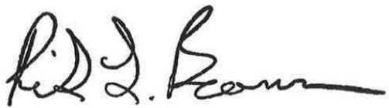

Rick Beaman

Chief Executive Officer

Attachments:

Exhibit A: Energy Broker Incentive Program