December 18, 2018

Nasdaq Futures, Inc.

FMC Tower, Level 8,

Christopher J. Kirkpatrick 2929 Walnut Street

Office of the Secretariat Philadelphia, PA 19104

Commodity Futures Trading Commission

Three Lafayette Center business.nasdaq.com/futures

1155 21st Street, NW

Washington, DC 20581

Re: **Rule 40.6(d) Notification**

**NASDAQ Futures, Inc. (“NFX” or “Exchange”)**

**Weekly Notification of Rule Amendments**

**Reference File: SR-NFX-2018-72**

Dear Mr. Kirkpatrick:

Pursuant to Section 5c(c)(1) of the Commodity Exchange Act, as amended (the “Act”), and Section 40.6(d) of the Commission’s regulations thereunder, NASDAQ Futures, Inc.

(“NFX” or “Exchange”) submits this notification of the following rule amendment made effective during the preceding week.

On December 7, 2018, the Exchange issued Futures Trader Alert #2018 – 39[1] announcing the initial listing of trading months in new NFX U.S. Midwest Domestic Hot-Rolled Coil Steel Index Financial Futures (HRCQ) on December 13th, for trade date December 14th. January 2019 was the first contract month available for trading. The trading months for the new contract, which were previously certified pursuant to Commission Rule 40.2 on December 7, 2018,[2] were set forth in the Futures Trader Alert as follows:

| **Rulebook  Appendix A Chapter** | **Name of Energy Futures Contract and Trading Symbol** | **Number of Contract Months Listed** | **First and Last Months** |
| --- | --- | --- | --- |
| 1101 | NFX U.S. Midwest Domestic Hot-Rolled Coil Steel Index Financial Futures (HRCQ) | 24 | Jan- 2019 Dec- 2020 |

If you require any additional information regarding this submission, please contact Aravind Menon at (301) 978-8416 or aravind.menon@nasdaq.com. Please refer to SR-NFX-2018-72 in any related correspondence.

Regards,

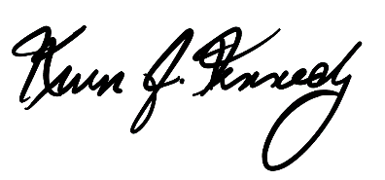

Kevin Kennedy

Chief Executive Officer

1. Available on the NFX website at [business.nasdaq.com/futures](http://business.nasdaq.com/).
2. See SR-NFX-2018-67.