December 30, 2019 Nasdaq Futures, Inc.

FMC Tower, Level 8,

Christopher J. Kirkpatrick 2929 Walnut Street

Office of the Secretariat Philadelphia, PA 19104 / USA

Commodity Futures Trading Commission

Three Lafayette Center business.nasdaq.com/futures

1155 21st Street, NW

Washington, DC 20581

**Rule Self-Certification: Rule Certification to Eliminate All Transaction Fees**

**Reference File: SR-NFX-2019-34**

Dear Mr. Kirkpatrick:

Pursuant to Section 5c(c)(1) of the Commodity Exchange Act, as amended (“Act”), and Section 40.6 of the Commission’s regulations thereunder, NASDAQ Futures, Inc. (“NFX” or “Exchange”) submits this self-certification to eliminate all transaction fees for futures and options on futures contracts listed on the Exchange. The rule change will take effect on January 14, 2020 for trade date January 15, 2020.

On November 12, 2019, NFX announced that it had sold the core assets of the Exchange to EEX Group. In light of the sale, the Exchange is encouraging market participants to close existing open interest (“OI”). The Exchange believes that elimination of all transaction fees will aide market participants in reducing or closing OI. The Exchange has reviewed the designated contract market core principles as set forth in the Act in connection with this amendment. The elimination of transaction fees will apply to all market participants for all contracts listed on the platform. Consistent with Core Principle 7 - Availability of General Information, the Exchange will post general information, including the NFX Rulebook as amended herein, on its website: [business.nasdaq.com/futures](http://business.nasdaq.com/nasdaq-futures/nfx-market).

**Certifications**

There were no opposing views among NFX’s Board of Directors, members or market participants. The Exchange hereby certifies that the rule amendment set forth herein complies with the Act and the Commission’s regulations thereunder. The Exchange also certifies that notice of pending certification and a copy of this submission have been concurrently posted on the Exchange’s website: [business.nasdaq.com/futures](http://business.nasdaq.com/nasdaq-futures/nfx-market).

If you require any additional information regarding this submission, please contact Aravind Menon at (301) 978-8416 or aravind.menon@nasdaq.com. Please refer to SR-NFX-2019-34 in any related correspondence.

Regards,

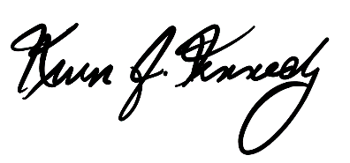

Kevin Kennedy

Chief Executive Officer

Attachment: Exhibit A – Fee Schedule (all transaction fees with a strikethrough are now $0.00 per transaction)