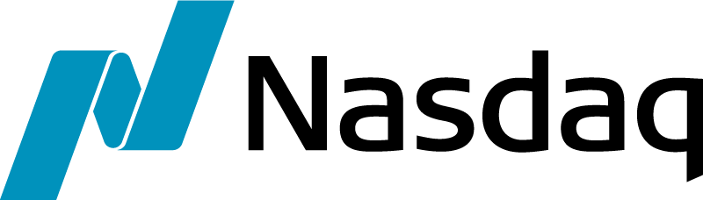
U.S. DV01 TREASURY FUTURES

NASDAQ FUTURES, INC. (NFX) CONTRACT SPECIFICATIONS

CONTRACT NAME | U.S. 2-YR DV01 Treasury Futures U.S. 10-YR DV01 Treasury Futures  U.S. 5-YR DV01 Treasury Futures U.S. 30-YR DV01 Treasury Futures
DESCRIPTION | Cash settled On The Run U.S. Treasury expressed as 100 minus the yield of the corresponding U.S. Treasury Note or bond (UST 2yr yield 1.98%; 100-1.98 = 98.02). The minimum trading tick increment is equivalent to two tenths (2YR) or one tenth (5YR, 10YR, 30YR) of the dollar value of one basis point (DV01) change in yield of the current On The Run U.S. Treasury as defined in contract rules.
UNDERLYING INTEREST | One hundred times the dollar value (DV01) assigned by the Exchange at the time of listing for each contract month, of a one basis point change in yield of the current On The Run U.S. Treasury security with a face value of $1,000,000 having fixed semi-annual coupon payments.
TICKER SYMBOLS | 2-YR = TUDV 5-YR = FVDV 10-YR = TYDX 30-YR = USDV | (Base Trading Symbols)
CONTRACT MONTHS | Up to 12 consecutive or non-consecutive monthly contracts, beginning with the nearest available month.
TRADING HOURS | 7:00 PM to 6:00 PM Eastern Prevailing Time (EPT) Sunday through Friday.
TRADING PLATFORM | Nasdaq Futures Inc. (NFX)
MINIMUM PRICE INTERVAL DOLLAR VALUE PER TICK | Outright and Spreads: Fractional Basis Point The increment between ticks equals the dollar value of  increments: 0.001 0.002 0.003 fractional basis points of the current OTR Treasury,  1.980% (100-1.980) equals 98.020 as defined in contract rules.*  1.981% (100-1.981) equals 98.019 UST 2yr equals $190 [0.002 = $38.00]  1.982% (100-1.982) equals 98.018 UST 5yr equals $460 [0.001 = $46.00]  1.983% (100- 1.983) equals 98.017 UST 10yr equals $860 [0.001 = $86.00]  1.984% (100- 1.984) equals 98.016 UST 30yr equals $1940 [0.001 = $194.00]  *For clarification, each contract month will be listed with an updated DV01 dollar value corresponding to the respective On The Run U.S. Treasury indicated in an NFX Futures Trader Alert.
DAILY SETTLEMENT PRICE | Quality Weighted Average Price (“QWAP”) shall be determined by reference to the Yield-Derived Price of best bids, best offers, and executed transactions in the corresponding U.S. DV01 Treasury futures on the Nasdaq Futures, Inc. (NFX) Trading System Order Book during the settlement period for the contract (the “Settlement Period”) as described in the Daily Settlement section of each product rule.
LAST TRADING DAY | 2-YR and 5-YR, the last NFX and NFI trading day of the contract month; trading ceases at 3 PM EPT.  10-YR and 30-YR, the 15th day of the contract month if an NFX and NFI trading day, otherwise the preceding NFX and NFI trading day; trading ceases at 3 PM EPT.
FINAL SETTLEMENT | Final settlement for contracts held to expiration is by cash settlement in U.S. dollars.
FINAL SETTLEMENT DATE | Final Settlement Date is the next business day on which the Options Clearing Corporation is open for settlement following the Last Trading Day.
FINAL SETTLEMENT PRICE | Closing Quality Weighted Average Price (“Closing QWAP”) shall be determined by reference to the yield of best bids, best offers, and executed transactions in the corresponding U.S. Treasury security on the Nasdaq Fixed Income (NFI) Alternative Trading System Order Book during the settlement period for the contract (the “Closing Settlement Period”) as described in the Final Settlement section of each product rule. The Final Settlement Price shall be calculated on the Last Trading Day.
CLEARINGHOUSE | The Options Clearing Corporation

MORE INFORMATION BUSINESS.NASDAQ.COM/FUTURES / FUTURES@NASDAQ.COM

© COPYRIGHT 2018

