Exhibit 3 to SR-NFX-2018-47

NFX DV01 Futures: Cash Market Description and Deliverable Supply

Contract Description
Nasdaq Futures Exchange (NFX) is proposing to list the U.S. 10-YR DV01 Treasury Futures (TYDG) futures contract. The new contract is listed pursuant to NFX Rulebook Appendix A, Chapter 2010, and is an interest rate contract based on yields of US Treasury (UST) securities. The remainder of this analysis applies to all U.S. DV01 Treasury Futures contracts listed or to be listed pursuant to NFX Rulebook Appendix A, Chapters 2002, 2005, 2010 or 2030 applicable to U.S. 2-YR DV01 Treasury Futures, U.S. 5-YR DV01 Treasury Futures, U.S. 10-YR DV01 Treasury Futures and U.S. 30-YR DV01 Treasury Futures, respectively.
Unlike existing products that involve the physically-settled delivery of Treasury Notes and Bonds, Nasdaq’s offering will be cash settled and settlement values will be directly tied to the current yields of UST securities. NFX contemplates listing contracts based on yields of securities with 2-, 5-, 10-, and 30-years to maturity. Each contract will cash settle based on the yield of the on-the-run UST security of that exact time to maturity. Reference prices used to determine final settlement will be derived from trading on the Nasdaq Fixed Income (NFI) UST cash market platform.
The quotation for the contract is based on the yield-to-maturity of a UST security, not the security price itself. Specifically, the contract is quoted as 100 – Yield, where the yield is expressed in percentage form to three decimal places. For example a yield of 2.761% corresponds to a quote of 97.239. This convention preserves the usual inverse relationship between the yield and contract value: as yield increases contract value decreases, and vice versa.
The notional size of the contract will be determined by applying a contract multiplier to the quotation. The multiplier will be based on the current sensitivity of the value of the underlying with respect to yield changes. This sensitivity is provided by the “DV01” of the underlying, defined as the change in bond value associated with a one basis point change in yield. The DV01 will be based on a security face value of $1 million. The precise level of the DV01 to be used for a given contract will be determined by NFX at the time of listing, and will remain constant during the life of the contract. The contract multiplier is 100 x DV01. Since a one basis point change in yield is represented as 0.01, the change in the value of a single contract associated with a one basis point change is 100 x DV01 x 0.01 = DV01. Thus, the dollar change in the notional value of the contact associated with a one basis point yield change will be approximately the same as the change in the dollar value of a $1 million security.
The proposed tick size for the 2-year contract is 0.002, and that for the others is 0.001. Since the current DV01 for the 2-year Note is about $190 (per $1 million of face value), the 2-year tick of 0.002 amounts to about $38 per contract. Current DV01’s for the 5-, 10- and 30-year securities are about $459, $849, and $1,939, implying contract tick amounts of about $46, $85, and $194.
Both daily and final settlement values will be determined by trading between 2:59 pm and 3:00 pm, ET. This timing is consistent with that of existing futures products offered on UST securities. Daily settlement prices will be drawn from NFX trading of the contracts themselves. Specifically, the settlement price will be the average of the one-minute VWAP of trades and the average one-minute bid/offer midpoint. In computing the overall average, the VWAP will receive twice the weight as the midpoint average. The determination of the final settlement price will follow the same methodology, but will be based on trades and quotes from the NFI cash market.

Issuance of Treasury Securities
The US Treasury, in order to fund the operations of the federal government, issues a wide range of debt securities. Among these are:
- Bills, short-term instruments that trade at a discount to par;
- Notes, instruments with maturities between 2 and 10 years that provide a semi-annual payment based on the Note’s fixed coupon rate;
- Bonds, similar to Notes but with maturities of 30 years; and
- Treasury Inflation Protected Securities (TIPS), coupon bearing instruments whose principal (i.e. face) value is indexed to general price inflation as measured by the Consumer Price Index.
The proposed NFX contracts are tied to Notes and Bonds with maturities of 2, 5, 10 and 30 years.
At periodic intervals, the Treasury conducts primary auctions of a set (face) dollar amount of securities. Currently, Notes with maturities of 2 and 5 years are auctioned on a monthly basis, while those of 10 and 30 years are auctioned quarterly. Regarding the latter however, issuances of 10- and 30-year securities are often “reopened,” meaning that additional amounts of a pre-existing security are auctioned. Often, quarterly 10- or 30-year auctions are followed by two monthly reopenings of securities placed in the original quarterly auctions.
Auction participants submit yield-based bids to the Treasury. The Treasury then determines the lowest bid that allows for the desired auction volume to be filled and all orders are filled at the single clearing price.
Treasury issuances placed during 2018 to date are indicated in the following table:

Amounts of UST Securities Issued 2018 to Date ($ billions)
Month | 2-Yr | 5-Yr | 10-Yr | 30-Yr
Jan | $26 | $34 | $20* | $12*
Feb | $28 | $35 | $24 | $16
Mar | $30 | $35 | $21* | $13*
Apr | $32 | $35 | $21* | $13*
* Reopening
During 2017 the average monthly amount auctioned by the Treasury was as follows:

Avg Monthly UST Issuance in 2017 ($ billions)
2-Yr | 5-Yr | 10-Yr | 30-Yr
$26 | $34 | $21 | $13

The figures show an increasing trend in amounts issued in 2018 over than of 2017. Given recent tax reform, it seems unlikely that the supply of recently-auctioned UST securities will decline in the near future.

Secondary Trading of UST Securities
With the primary auction complete, secondary trading of UST securities begins. By industry convention, the most recently auctioned securities of a given maturity are referred to as “benchmark” or “on-the-run.” Once a new tranche is issued, formerly on-the-run securities become “off-the-run.” A given tranche of 2- and 5-year Notes therefore have a one month on-the-run period while the 10- and 30-year instruments are on-the-run for a quarter. Trading volume of on-the-run securities tends to be much higher than off-the-run.
The secondary trading of UST securities has evolved into two broad segments: Dealer-to-Customer and Inter-Dealer. The Dealer-to-Customer segment involves institutions, insurance companies, foreign central banks, and other end users trading with sell-side dealers, traditionally large banks. The inter-dealer segment, as the name implies, has traditionally been a market in which the dealers trade with each other to manage inventory, presumably to facilitate their customer-facing business. The inter-dealer segment operates on platforms provided by Inter-Dealer Brokers (IDBs). NFI is an example of such an IDB. Other IDBs trading UST securities include the BrokerTec platform operated by NEX Group, and the Dealerweb platform operated by Tradeweb.
During the last two decades, the IDB trading of on-the-run UST securities has become increasingly all electronic (as opposed to voice brokered). Currently trading of on-the-run issues is virtually entirely carried out on electronic order books. Another important development has been the increasing role played by Principal Trading Firms (PTFs). PTFs are firms that do not hold customer accounts. Rather, they trade entirely for the firm’s principal account. PTFs are also characterized by their extensive use of high-speed computerized trading strategies. Since they do not deal with customers, PTF’s presence in the IDB markets is not to facilitate customer business. Instead, their trading is motivated by finding opportunities for short-term trading gain from exploiting arbitrage opportunities or acting as market makers on the platforms.
It is difficult to precisely measure the size of the secondary market in UST. Unlike stocks, there is no centralized, public data feed providing real-time prices and volumes. Greater transparency may be forthcoming, however, due to the recent addition of UST securities to FINRA’s TRACE program. TRACE data for Treasuries has not been publicly disseminated.
A limited public source of volume levels and trends in UST securities can be obtained from weekly surveys conducted by the New York Fed. The New York Fed surveys its “primary dealers” to learn of their transaction volume in UST. The primary dealers, currently numbering 23 firms, act as counterparties to the New York Fed in its implementation of monetary policy. The following chart shows reported daily average volume (in $ millions), broken down by type of counterparty: Customer vs Inter-Dealer Broker. The chart shows figures from January 2015 through March 2018:
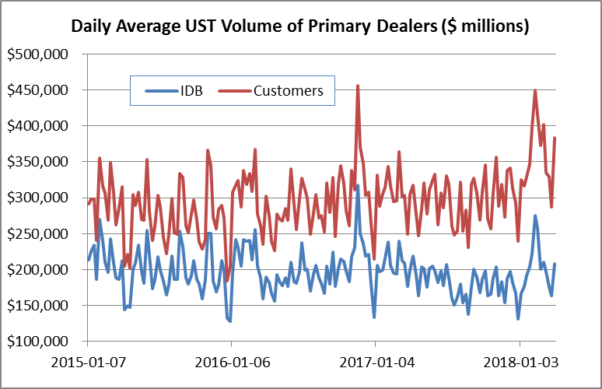
The chart indicates, roughly, Customer volume of about $300 billion per day, and trading on Inter-Dealer Brokers of about $200 billion per day. During the last year, volume with Customers appears to have increased somewhat, while that with IDBs has declined. There are some important caveats to keep in mind in interpreting the data. First, trades are reported for all UST securities, not just those on-the-run. Second, the IDB figures may include some double counting of volume, because primary dealers often trade with each other on IDB platforms. Third, perhaps most importantly, the survey only covers primary dealers, ignoring smaller banks and Principal Trading Firms. As will be discussed in detail below, PTFs play a very important part of the IDB marketplace.

Background on NFI
The final settlement prices for the proposed NFX contracts will be based on observed prices from Nasdaq’s NFI UST platform. NFI, at the time known as eSpeed, was acquired by Nasdaq in 2013 from BGC Partners. Established in 1996 by Cantor Fitzgerald, eSpeed was the industry leader in the adoption of all-electronic trading of UST securities. Cantor Fitzgerald spun off eSpeed as an independent, publicly-traded company in 1999. eSpeed later merged with BGC Partners in 2008.
NFI facilitates matching of subscriber orders in U.S. Treasury securities and is operated by Execution Access, LLC (EA), a subsidiary of Nasdaq, Inc. EA is registered with the U.S. Securities and Exchange Commission as a broker-dealer and is a member organization of the Financial Industry Regulatory Authority (FINRA). Subscribers to NFI are institutional entities, primarily banks, broker-dealers and proprietary trading firms. Orders entered by subscribers may interact with other subscriber orders. EA does not trade in a principal capacity, with the exception of offsetting a bona fide error position through its error account.

The majority of NFI’s volume is in the six benchmark on-the-run UST securities, having maturities of 2, 3, 5, 7, 10, and 30 years. NFI can be characterized as an electronic Central Limit Order Book (CLOB). The system accepts non-marketable limit orders which rest on the book. Incoming marketable orders are matched against the resting orders on the basis of price/time priority (i.e., for a given price, the oldest resting order is matched first).
The standard NFI trading lot size is $1 million of face value. Prices are quoted in terms of percentage of par value (e.g. 98, 101) with fractional amounts expressed in 32nds of a point. The current tick size for 2- and 5-year Notes is one-quarter of 1/32nd. In decimal terms, this tick is 0.78125%, or about $78 for a lot of $1 million. For 10-year notes and the 30-year bond, the tick size is one-half of 1/32nd, which in decimals is 1.5625%, or about $156 for a $1 million lot.
NFI operates 22 hours per day, from 7:30 pm ET through 5:30 pm ET the following day. These hours accommodate the global demand for UST securities. The 22-hour period can be roughly divided into the Asian, European, and North American sessions.
The following table shows average NFI daily volumes (in $millions) for the indicated on-the-run security.

Average Daily NFI Volume ($ millions) by Quarter
Quarter | 2-Year | 5-Year | 10-Year | 30-Year
2015.1 | 9,202 | 21,292 | 16,312 | 2,469
2015.2 | 9,204 | 19,948 | 16,402 | 2,432
2015.3 | 9,146 | 17,976 | 13,529 | 2,194
2015.4 | 6,062 | 14,321 | 9,690 | 1,632
2016.1 | 6,903 | 16,713 | 12,159 | 1,543
2016.2 | 6,499 | 13,384 | 10,028 | 1,242
2016.3 | 6,003 | 11,351 | 9,278 | 1,494
2016.4 | 6,677 | 14,378 | 10,990 | 1,779
2017.1 | 5,760 | 14,328 | 9,526 | 1,541
2017.2 | 6,001 | 12,173 | 9,001 | 1,480
2017.3 | 3,682 | 11,378 | 8,294 | 1,433
2017.4 | 4,704 | 11,127 | 8,133 | 1,560
2018.1 | 5,959 | 14,341 | 11,115 | 1,931

The proposed daily and final settlement procedures call for volume and quotation information from 2:59 pm to 3:00 pm ET, consistent with practices of existing futures contracts. The following chart shows the relative level of NFI volume for the indicated securities from 2:30 pm through 3:30 pm. The chart breaks down volume by minute increment.
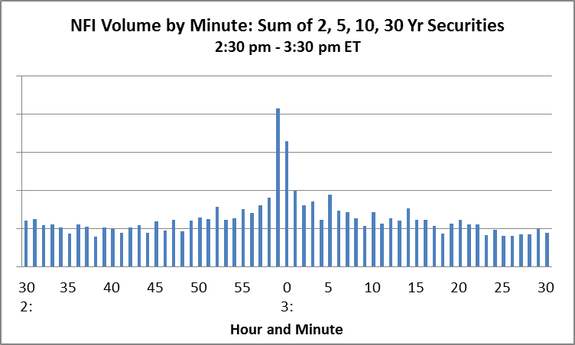
There is clearly a volume spike immediately before and after 3:00 pm, indicating the connection between futures settlement and the cash market. Indeed, by industry convention, the 3:00 pm price for a UST security represents something of a “closing” price, even though trading continues after this time. This finding illustrates that liquidity in UST securities is highest at the time designated for determination of settlement prices.

NFI Oversight
As mentioned above, NFI is operated by a registered broker-dealer and FINRA member. In the NFI Trading Manual, EA acknowledges its regulatory obligation to ensure that Subscribers’ and their authorized traders’ activities on NFI are conducted in compliance with federal, state and self-regulatory organization laws, rules and regulations. In accordance with these objectives, EA states that it will seek to maintain at all times a fair and orderly market to ensure that NFI is not used for any improper purpose, including but not limited to fraud, manipulation and disruptive or deceptive practices. EA has implemented both operational and compliance best practices including those as advised by industry groups, such as the Treasury Market Practices Group, to promote and maintain the integrity and efficiency of NFI and the overall U.S. Treasury market as well as a robust internal-control environment. The Trading Manual makes clear that, as a registered securities broker-dealer, EA has responsibilities under SEC and FINRA rules to surveil for market manipulation, fraud, and disruptive and deceptive activities on NFI, including giving the false impression of market price, depth or liquidity (e.g., layering or spoofing, painting the tape, and improper self-matching); inhibiting the provision of liquidity by others causing undue latency or delays in other Subscribers executions (e.g. throttling); deliberately acting to cause error trades; and causing or exacerbating settlement failures.

Intermarket Linkage.
Unlike the case with equities, there is no publicly-available data feed that consolidates UST trading information from the IDBs or from dealers trading with customers. Thus there is no direct empirical data as to the precise relative sizes of the various markets. Nasdaq believes that NFI is the second-largest IDB behind BrokerTec, with market share approximating 20%. In assessing the overall liquidity of a given single market, however, it is important to recognize the linkages that exist between markets. These linkages are based on the presence of market participants that simultaneously trade on multiple markets. These linkages work towards amplifying the liquidity on any given market.
Evidence for this point is provided by the Joint Staff Report that was created in response to the unusual volatility in the Treasury market on October 15, 2014. The agencies that created the report obtained participant-level order book information from both BrokerTec and eSpeed (as NFI was then called). Much of the analysis presented in the report is based on the BrokerTec data, though it was determined that the levels of concentration and participation levels were found to be similar across both platforms (page 12, fn 10). The study also used similar participant-level data from the CME, the operator of the Treasury futures markets. The study provides a useful view into the UST cash market as it stood in the fall of 2014.
Among the key findings of the report is the high level of PTF participation in the cash market on both the high volatility period of October 15 as well as in less volatile periods. Across all instruments, PTFs account for roughly half of volume. Further, this volume is highly concentrated among the top 10 PTFs (page 59, tables 3.3 and 3.7). Nasdaq concurs with the study that similar levels of PTF participation exist on NFI. The significance of this finding is as follows. Of all market participants, PTFs are arguably the most inclined and able to observe and exploit cross-market pricing differences. This inclination is tied to their focus on finding short-term profit opportunities. The widespread presence of PTFs ensures that pricing across multiple cash markets is uniform. Temporary dislocations in one market would be quickly be arbitraged away.
The report makes a similar point concerning the linkages between the cash market and the futures market. For instance, it was found that trades by the top 10 PTFs in 10-year futures were frequently followed by trades by the same firms in the 10-year cash market, with roughly a 5 millisecond lag. This lag is just above the theoretical minimum latency between the Chicago-area data center serving futures and the eastern New Jersey data centers serving the cash markets (page 53).
Again, the key point is that the “market” for UST is larger than any single CLOB. Linkages between various cash and futures platforms combine to create virtual pools of liquidity far larger than that observed on any individual pool.

Deliverable Supply Analysis
NFX presents the following deliverable supply analysis using information provided by the US Treasury. Consistent with Core Principle 3 of the Commodity Exchange Act, and Appendix C to Part 38 of the CFTC’s rules, NFX bases the definition of deliverable supply as those benchmark UST securities that are currently on-the-run, meaning that they represent the most recently issued tranche of securities for a given maturity, which for purposes of the proposed contracts are 2, 5, 10, and 30 years. Below is guidance provided for in Appendix C to Part 38.
In general, the term "deliverable supply" generally means the quantity of the commodity meeting a derivative contract's delivery specifications that can reasonably be expected to be readily available to short traders and saleable by long traders at its market value in normal cash marketing channels at the derivative contract's delivery points during the specified delivery period, barring abnormal movement in interstate commerce.
The table below shows US Treasury monthly issuance amounts from 2015-2017. As can be immediately seen, the monthly amounts are quite consistent, exhibiting minor occasional shifts. In the case of the 10- and 30-year securities, initial auctions are held quarterly on a Feb/May/Aug/Nov cycle, with slightly smaller re-openings held on the other months.

Monthly US Treasury Issuances of Benchmark Securities ($ billions)
 | 2-yr | 5-yr | 10-yr | 30-Yr
2017
Jan | $26 | $34 | $20 | $12
Feb | $26 | $34 | $23 | $15
Mar | $26 | $34 | $20 | $12
Apr | $26 | $34 | $20 | $12
May | $26 | $34 | $23 | $15
Jun | $26 | $34 | $20 | $12
Jul | $26 | $34 | $20 | $12
Aug | $26 | $34 | $23 | $15
Sep | $26 | $34 | $20 | $12
Oct | $26 | $34 | $20 | $12
Nov | $26 | $34 | $23 | $15
Dec | $26 | $34 | $20 | $12
2016
Jan | $26 | $35 | $21 | $13
Feb | $26 | $34 | $23 | $15
Mar | $26 | $34 | $20 | $12
Apr | $26 | $34 | $20 | $12
May | $26 | $34 | $23 | $15
Jun | $26 | $34 | $20 | $12
Jul | $26 | $34 | $20 | $12
Aug | $26 | $34 | $23 | $15
Sep | $26 | $34 | $20 | $12
Oct | $26 | $34 | $20 | $12
Nov | $26 | $34 | $23 | $15
Dec | $26 | $34 | $20 | $12
2015
Jan | $26 | $35 | $21 | $13
Feb | $26 | $35 | $24 | $16
Mar | $26 | $35 | $21 | $13
Apr | $26 | $35 | $21 | $13
May | $26 | $35 | $24 | $16
Jun | $26 | $35 | $21 | $13
Jul | $26 | $35 | $21 | $13
Aug | $26 | $35 | $24 | $16
Sep | $26 | $35 | $21 | $13
Oct | $26 | $35 | $21 | $13
Nov | $26 | $35 | $24 | $16
Dec | $26 | $35 | $21 | $13

Information on US Treasury auctions is available at: https://www.treasurydirect.gov/instit/annceresult/press/press_auctionresults.htm.
See http://www.finra.org/newsroom/2017/finra-successfully-launches-reporting-treasury-transactions.
See https://www.newyorkfed.org/markets/primarydealers.
Source: https://www.newyorkfed.org/markets/gsds/search.html#.
Sources: http://ir.nasdaq.com/releasedetail.cfm?releaseid=774689; http://www.cantor.com/; http://www.bgcpartners.com/bgc/history/.
See Joint Staff Report: The U.S. Treasury Market on October 15, 2014, prepared by representatives of the U.S. Treasury, Commodities and Futures Trading Commission, Securities and Exchange Commission, Board of Governors of the Federal Reserve, and the New York Fed. Available at: https://www.treasury.gov/press-center/press-releases/Documents/Joint_Staff_Report_Treasury_10-15-2015.pdf.
See https://www.treasurydirect.gov/instit/annceresult/press/press_auctionresults.htm.
http://www.cftc.gov/idc/groups/public/@lrfederalregister/documents/file/2012-12746a.pdf

